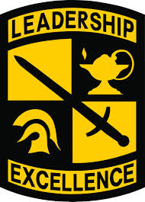
Ram Battalion Marist ROTC
Operation 24 Packing List

- Backpack or athletic bag
- Notebook, pen or pencil
- Running shoes
- Workout clothes (For Physical Training)
- Appropriate outfit for college classes
- Boots/Hiking Shoes/Shoes you don’t mind getting dirty (For Tactical Lab)
- Personal Hygiene items (towels, toothbrush, soap, etc.)
- Medical Items (Medicine, aspirin, etc.)
- Cell Phone
- Photo ID (Needed to enter Residence Halls)
- Weather appropriate clothing (Rain gear, sweatshirt, jacket, etc.)
- Sleeping bag and bedding (Check with your host to see if this is necessary)
- Small amount of cash ($20 is recommended)

Most of all bring a positive attitude and a loud voice!

