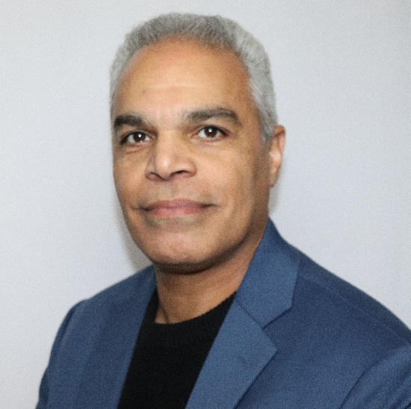

**Edison Guzman**

**President of Prosperity Marketing, LLC**

Search Engine Optimization (SEO), Search Engine Marketing (SEM), Pay Per Click campaigns (PPC), Social Media Management (SMM), Copywriting, Online Funnel Creation, Email Marketing, Video Marketing, eCommerce and Content Marketing.

Edison is also past President of the Greater Monroe Chamber of Commerce as well as past President of the Orange Chapter of SCORE #465.

He is also Board Emeritus of Garnet Health and past board member at the Orange County Chamber of Commerce.

Edison is currently Board Member of the Business Council of Greater Montgomery, and is creator of the Entrepreneurial Success Program, 10-week course teaching individuals to build a business plan and discover all facets of running a successful business.